

PRANTIK SME

Software Requirements Specification Document

Small and Medium Enterprise System

Version No: - 1.00

|  |  |  |  |
| --- | --- | --- | --- |
| Prepared By | Reviewed By | 2nd Reviewed By | Approve By |
| Chitto Ranjan Sarkre |  |  |  |
|  |  |  |

**Introduction:**

Save time and eliminate paperwork by automating the business Process. Proprietor can registration a business account then create stock, sales and sales man account using by web Interface. This automated system help to play a business with all update information which need a businessman.

**Overview of Functional Requirements:**

1. Authorized users (Proprietor) must be able to login with their identification number or user name and password.
2. After a successfully registration Proprietor can create Business Admin, Stock, Sales, Salesman account and many activities which provide by the system administrator.
3. After a successful login the user (Business Admin) can do an operation which is authorized by the Proprietor (Create Stock, Create Sales, Create Salesman account, View report, etc.).
4. After login user (Salesman) may do some operations, Like- Create a Customer account with sales and print, see sales report by using customer information, etc.

**Security System:**

Only Authorized user will be permitted to access the system. This system will provide the user’s with a secure way to change their information.

**Goal:**

Eliminate paperwork and fluently play business with all update information and data.

**What problem it will solve?**

1. Traders do business with this software without any paperwork.

2. The grocery shopper can create stocks and sales.

3. The owner can create his employee list with the permission of the employee details and role base.

4. Reduce paperwork and time to solve business details.

**What is vision and mission for software?**

**Mission:**

To achieved business goal by reduce paperwork and time to maintenance business.

**Vision:**

Play business with modern technology and quickly monitor details status.

**Scope of the System:**

The project aims at providing an efficient interface to the Grocery Shopper for managing their business from manual process to automation. This software work for decrees paper work, maintenance sales and stock. Also work for maintenance employee details information’s.

**The Domain:**

This project aims to management of a Grocery Shop. It can be used in large domain would result in an equally as large scope of development. To keep that in mind we kept our software case study client Grocery shop as priority to build a satisfying project.

**The Client:**

Our software work for maintenance a Grocery Shop with manage stock, sales product, manage salesman activity and generate report which need to play a business. So this product work for a Grocery business.

**The User:**

The main users of the product would be employee who sales product. A salesman sale store product to a buyer and put all details information about sales in this database. Admin can take an action about salesman, stock and sales activities. Like as create salesman, stock and sales.

The main user of this software is proprietor as Master Admin. Master Admin can control his own business all kinds’ activities. Master Admin after registration Grocery shop can create admin and create salesman, stock, sales, generate report, deactivate employee, etc.

**User Type:**

1. Proprietor (Can control everything in system)

2. Sales Admin (Can control sales store details)

3. Sales Man (Can sales)

**Stakeholder:**

1. Proprietor

2. Sales Admin

3. Sales Man

4. Buyer (Get notification on mobile for sales details)

**Feature:**

1. Salesman sales product to buyers. (Scenario-1)

2. Store admin can edit sold product for adjust. (Scenario-2)

3. Store admin can create and update stock.

4. Store admin can create and update product price.

5. Proprietor can create Store admin and Salesman account and control all activities

to provide his business. (Scenario-3)

6. Proprietor have permission to deactivate his business account.

**Scenario:**

**Scenario 1:**

Salesman can create customer account and sales product with money received. Also received money from customer. Salesman have no permission to edit sales or update stock.

**Scenario 2:**

Store Admin have permission to edit sold product for readjust stock. Store Admin can create product price, product price update, stock create, stock update and generated store related report. Store Admin work have some limitation which control by Proprietor.

**Senerio3:**

The Proprietor create his account with details information. After registration Proprietor can create Store Admin, Salesman account with details. Proprietor have permission to crate his/her employee role and permission. He/ She can control his all business activities.

**Context Diagram:**

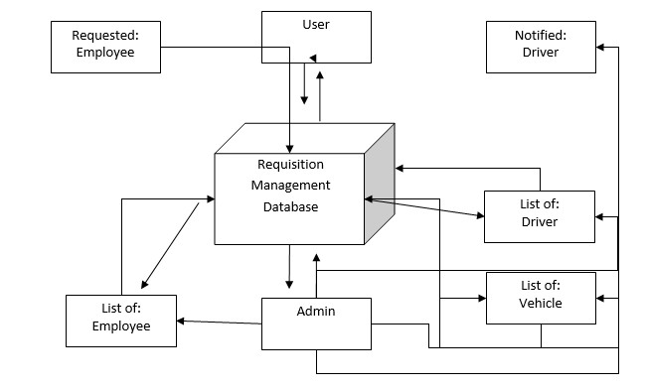

**Persona:**

**1. Proprietor:**

The person who is responsible for setting up and maintaining the store account is called the Proprietor. Proprietor have all permission to manage his business account. Proprietor need to create some role for his business and give role permission.

1. Create Store Admin (Mange Sales Store Activities).

2. Create Salesman (Sales product form store)

**2. Store Admin:**

Store Admin have some responsibility to manage sales store. He have some permission to manage business which given by Proprietor.

1. Store Admin create and update stock.

2. Store Admin can update sales for adjust stock.

3. Store Admin can view and generated some report for sales store.

**3. Salesman:**

Salesman have the main user of this software. They have some role to play the business.

1. Salesman can sale product from store.

2. Salesman can create customer account.

3. Salesman can print money receipt for every sales.

**User Stories:**

Back Log for Proprietor:

1. As a System Administrator I want to Create Vehicle Manager. So that I can easily manage vehicle manager.
2. As a System Administrator I want to create vehicle list. So that manage all vehicle.
3. As a System Administrator I want to create a driver list. So that I can manage driver.
4. As a System Administrator I want to create employee list. So that I can make an employee as a user.
5. As a System Administrator I want to deactivate vehicle, Employee and driver. So that I can check all activities.

Backlog for Store Admin:

1. As a vehicle controller I want to requisition search option. So that I can view all requisition status.
2. As a vehicle controller I want to approve requisition. So that I can assign a vehicle to an employee.
3. As a vehicle controller I want to cancel or delete requisition. So that I can make decision to assign a vehicle or not.
4. As a vehicle controller I want to reassign requisition. So that I can easily re-assign a vehicle on requisition.
5. As a vehicle controller I want to control vehicle check-in or check-out. So that I can easily guess which vehicle and driver are available?
6. As a vehicle controller I want to send confirmation mail or message to employee and driver. So that they can insure for their trip.
7. As a vehicle controller I want to discuss with the requester by message. So that we can easily contact with requester on this request.

Backlog for Salesman:

1. As an Employee I want to access the system. So that create a login option.
2. As an Employee I want to send a requisition for vehicle. So that I can get a vehicle for trip.
3. 101As an Employee I want to cancel requisition. So that I can cancel my request.
4. As an Employee I want to get a confirmation message in mail or mobile. So that I will insure for my vehicle assign.
5. As an Employee I want to print requisition copy. So that I can get a document for trip.
6. As an Employee I want to communicate with vehicle controller on the request. So that I can instant discuss about assignable vehicle and driver with messaging.
7. As an Employee I want to see my all vehicle requisition list. So that I can informed about my request and view my requisition details.

**System Development Environment:**

**Application Development:**

1. Visual Studio 2017
2. ASP .NET MVC 5 ( Repository Pattern with 3 tire architectures)
3. Entity Framework 4.6 (Code first approach)
4. HTML-5, CSS-3 and Bootstrap 3.7.7
5. Javascript & JQuery- 3.1

**Application Database:**

Microsoft SQL Server -2014

**Use Case Diagram:**

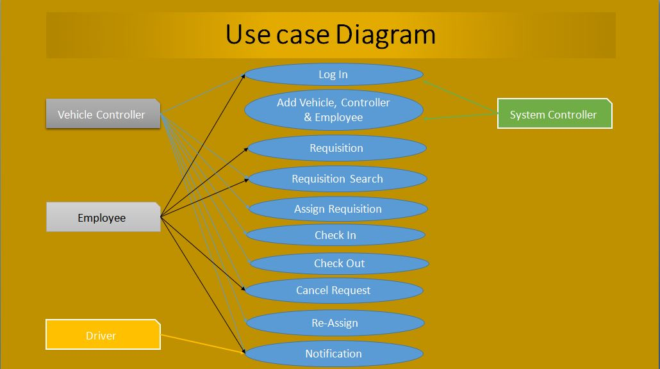

**Fig: Use Case Diagram**

**ER-Diagram:**

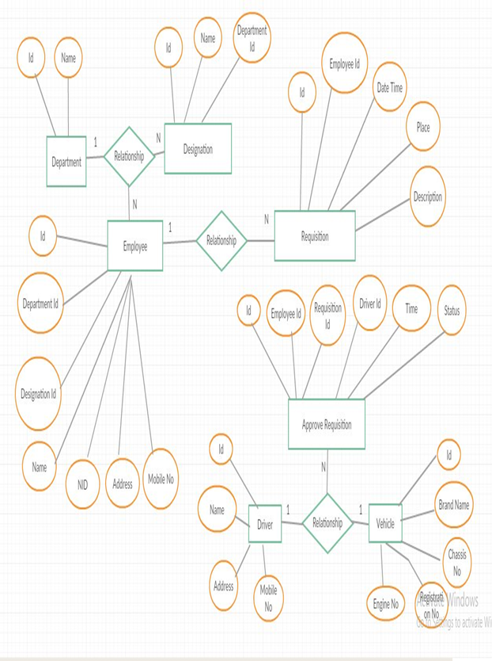

**Fig: ER-Diagram**

**Class Diagram:**

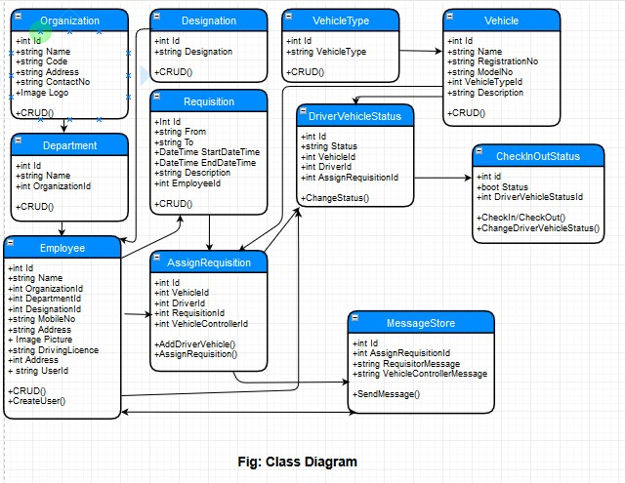

**Fig: Class Diagram**

**Workflow Diagram:**

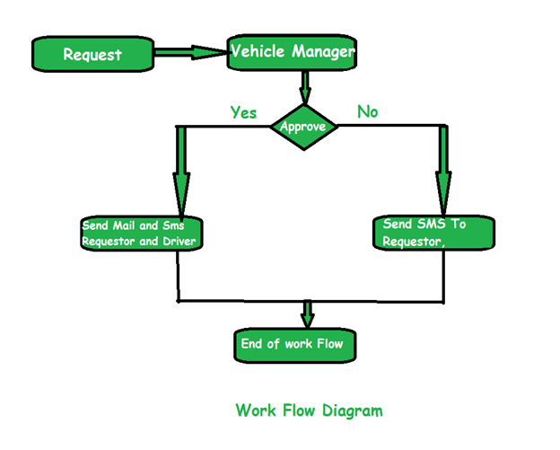

**Fig: Work Flow Diagram**

**Activity Diagram:**

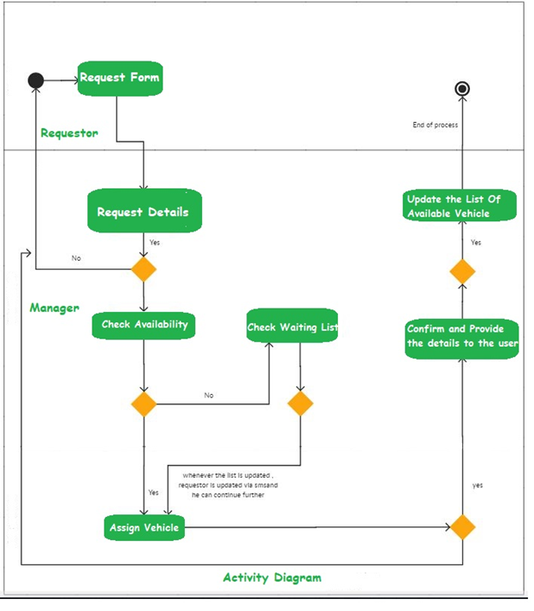

Fig: Activity Diagram

**Data Flow Diagram:**

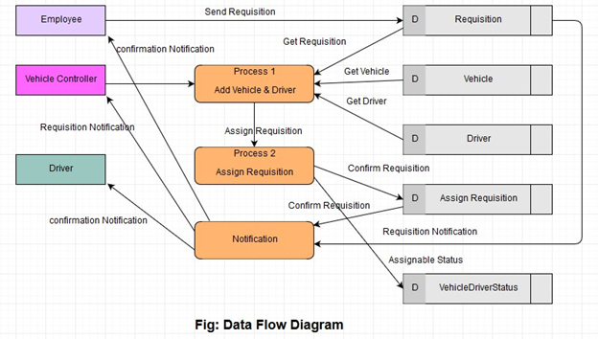

**Sequence Diagram:**

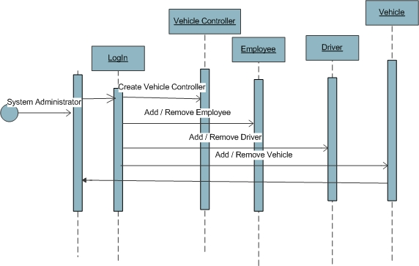

**Fig: Sequence Diagram of System Administrator**

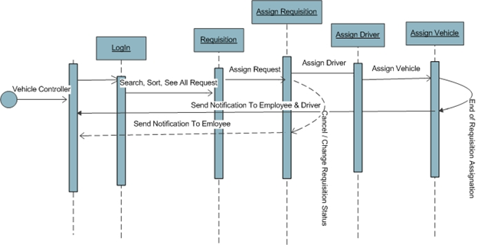

**Fig: Sequence Diagram of Vehicle Controller**

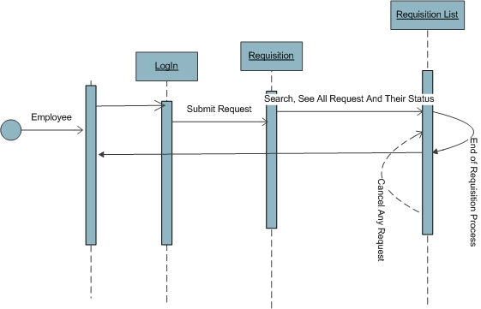

**Fig: Sequence Diagram of Employee**

**Wire Frame:**

**Employee Profile:**

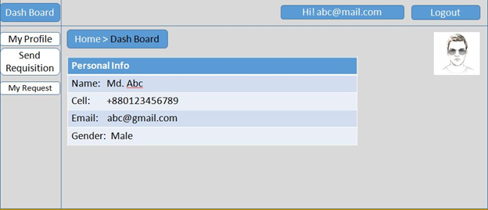

**Request Form:**

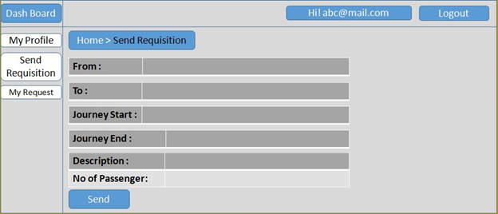

**List of Requisition:**

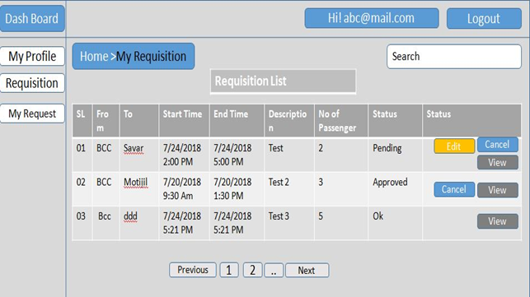

**Vehicle Manager:**

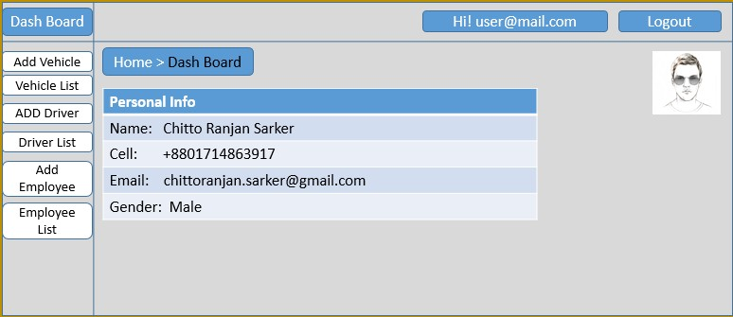

**Add Vehicle:**

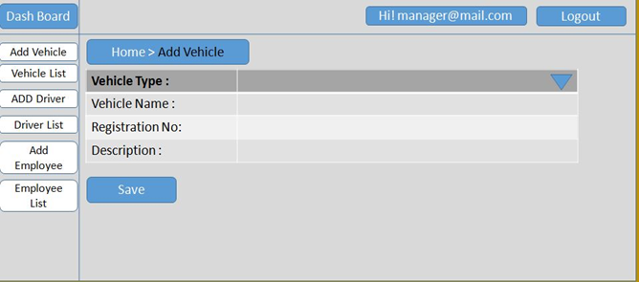

**Vehicle Type List:**

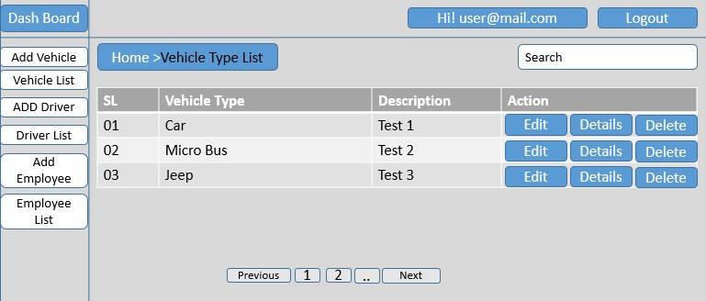

**Add Driver:**

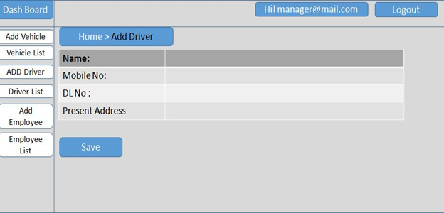

**Driver List:**

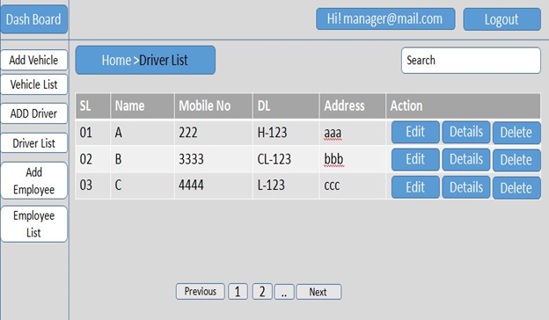

**Add Department:**

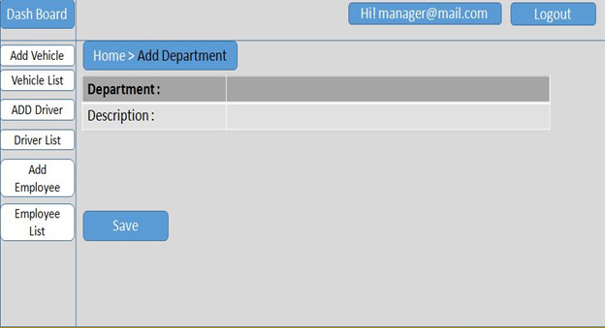

**Department List:**

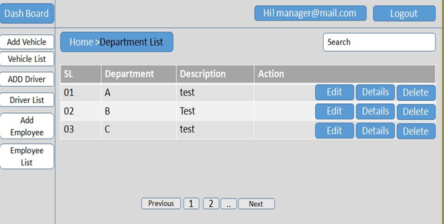

**Add Designation:**

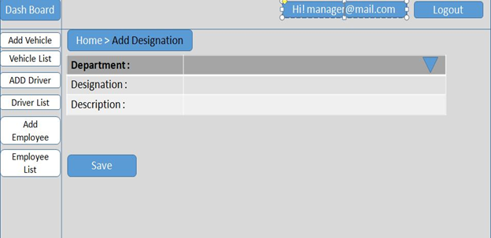

**Designation List:**

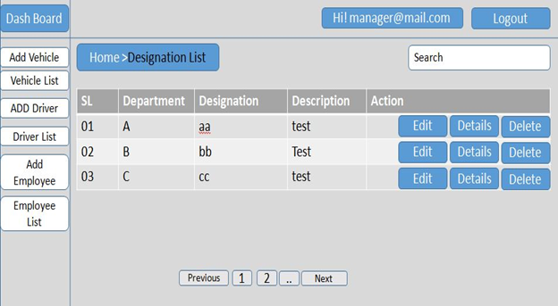

**Add Employee:**

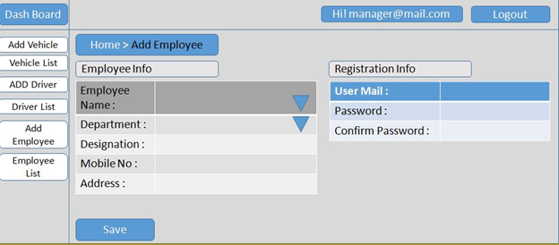

**Employee List:**

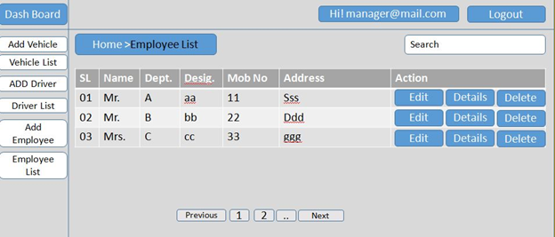

**Requisition List:**

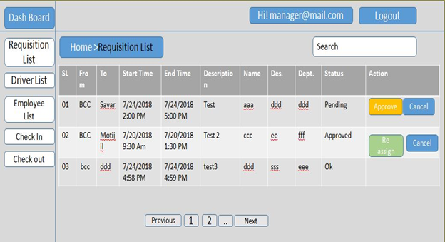

**Vehicle Assign Form:**

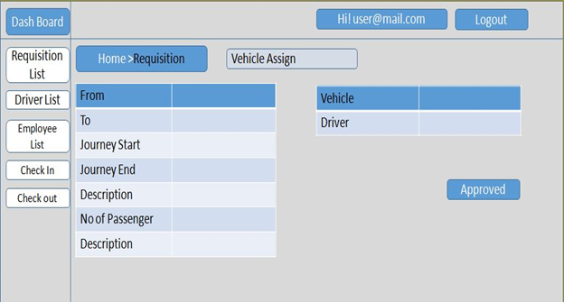

**Check-out Form:**

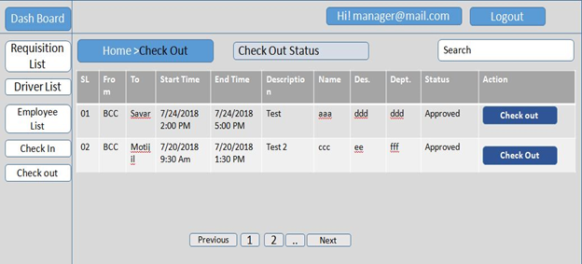

**Check-in Form:**

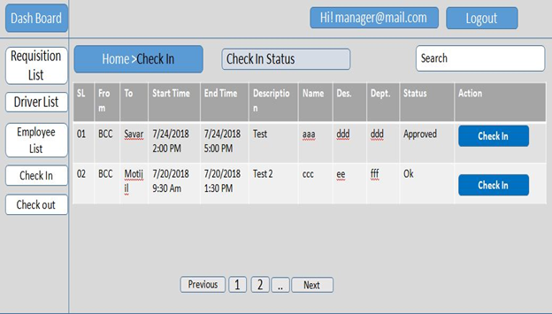

**Developed By:**

|  |  |  |  |
| --- | --- | --- | --- |
| **Sl** | **Name** | **Mobile No** | **Email** |
| 1 | Md. Enamul Hoque | 01817-009653 | parvezfci@gmail.com |
| 2 | Chitto Ranjan Sarker | 01714863917 | Chittoranjan.sarker@gmail.com |
| 3 | Hamidul Islam Sumon | 01945582211 | hamid4723@gmail.com |
| 4 | Md. Ziaul Talukder | 01728388751 | mohammadziaulm62@gmail.com |
| 5 | Md. Kazi Shala Uddin | 01913935800 | shalauddin99@gmail.com |
| 6 | Lutfunnessa Sultana | 01681854486 | Luth.sul@gmail.com |
| 7 | Al Mamun Mollah | 01716986506 | amollah55@gmail.com |
| 8 | Mosammat Benajeer Hoque | 01791057663 | benajeerhaque15@gmail.com |
| 9 | Md. Masum Bellal | 01744401313 | dollar1194@gmail.com |
| 10 | Mohammad Alimuzzaman | 01819127664 | alimuzzaman@gmail.com |
| 11 | Md. Khalid Hossain | 01720279279 | khalidhossainbd@gmail.com |
| 12 | Md. Shiheb Uddin | 01866951319 | shihabbu056@gmail.com |